### 

|  |  |
| --- | --- |
| **Category** | Technical Test |
| **Department** | Product Development |
| **Position** | Senior Reactjs Developer |

### 

### Requirement

Create simple project for movies ticket. Choose movie, click buy seat, notify the user and create transaction as json file. Simple as that!

* Lists of movies should come from Database (Json files)
* Lists of seats should come from Database (Json files)
* Transaction should save as json format
  + Should save normal transaction sheets (example: movies id, name, price, currency etc.)

Here are rough wireframe.

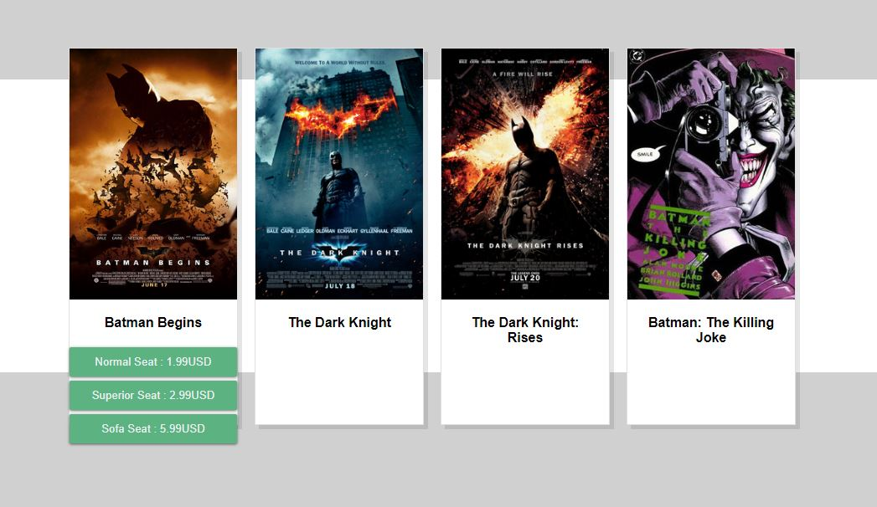

**Task that your are need to completed**

1. UI integration
   1. Complete the UI with your idea
   2. Responsive design
2. UX/UI Integration
   1. Provide the notify message however you want when make purchased.
   2. Leave to your imagination where did you want to improve.
3. React / Redux
   1. Using React (of course) for implementing
   2. Using Redux.

**Bonus**

1. Create Movies detail ( or other page ) and mapping by React-router to define component and path.
2. Using Redux-sagas.

You can do freely in your project and use package whatever you want :)

### Specifics

#### How to submit your assignment?

* Create a repository on Github
* Once your assignment is completed, send us the link to your repository.

#### How will you be evaluated?

* Code documentation & style.
* Language/Platform features utilization.
* Project Structure (file/folder organization).
* Architecture (components, areas of responsibility).
* Complexity (easier to understand code is better).
* Unit / Integration Tests.
* Git commit messages.